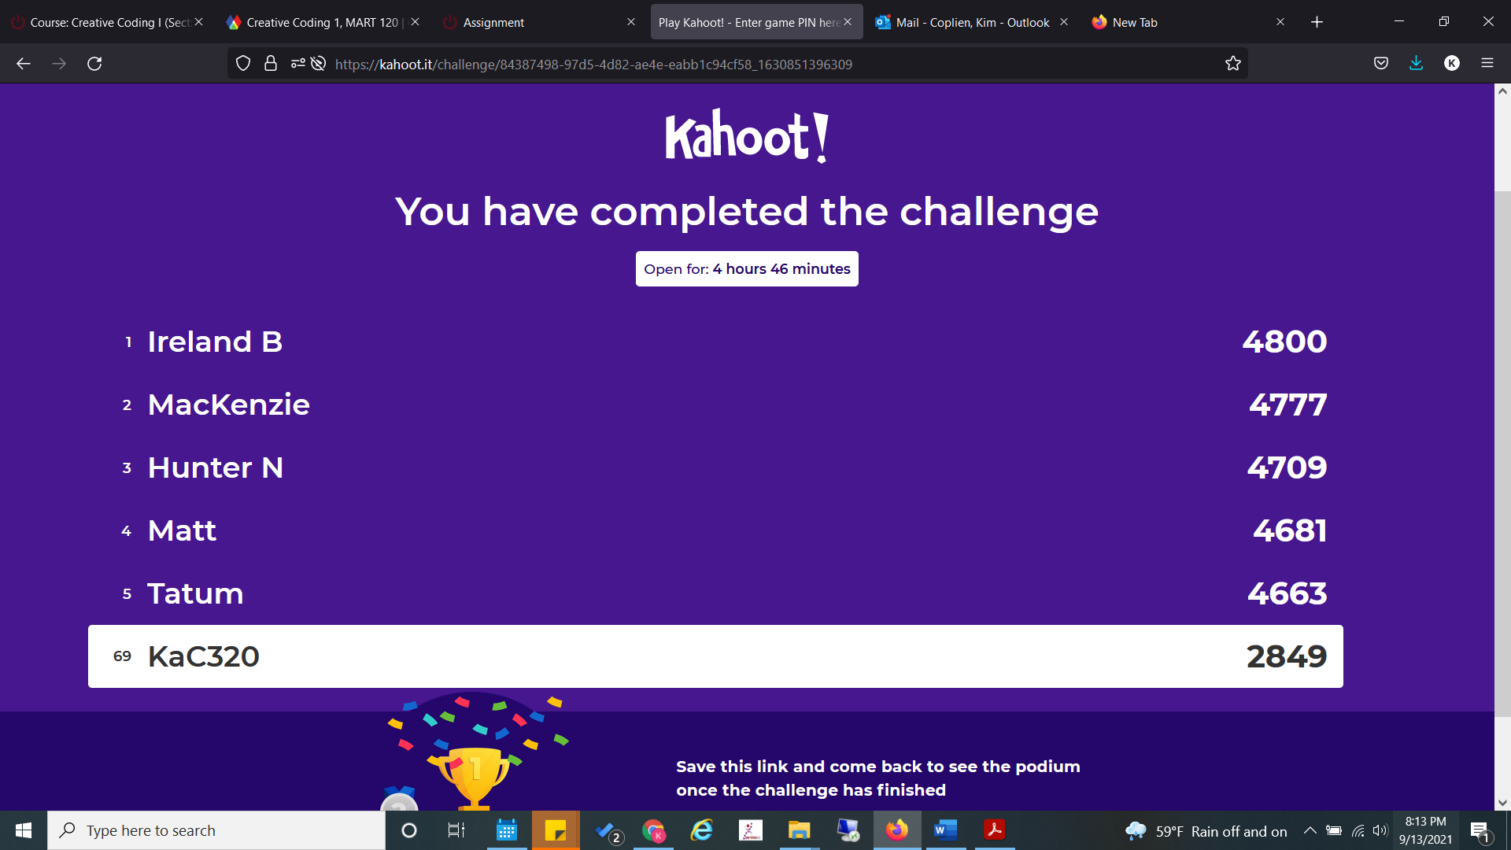

https://kahoot.it/challenge/84387498-97d5-4d82-ae4e-eabb1c94cf58_1630851396309?&uid=S2FDMzIw